Biological invasions | Home
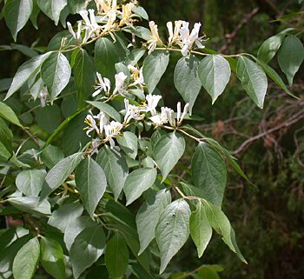 | Effect of landscape structure on invasion dynamics of the invasive shrub Lonicera maackii  Invasive non-native species often have negative effects on the ecology and productivity of forests and other wildlands. Determining how invasive species spread and what sites are at risk of invasion are important for their early detection and control.  In our work, we try to determine how landscape patterns shape invasion of one of the non-native ‘bush honeysuckles’ that are serious problems in eastern and Midwestern U.S. forests, Amur Honeysuckle. The first objective is to document the historical expansion of Amur Honeysuckle into stands (woodlots and forests) within an agricultural landscape over the last 20 years in three counties in southwestern Ohio using satellite images. Because this shrub expands its leaves earlier and retains them later than native trees and shrubs, invaded stands can be distinguished using satellite images. Second, we are developing a predictive model for how landscape characteristics, including fragmentation and corridors, shape the pattern and rate of invasion. Third, we will test this model by predicting the likelihood of new invasions in stands at the edge of the current range, and inspecting these stands for newly established individuals. Fourth, we will test whether seed dispersal processes implicated in the predictive model are supported by genetic data, specifically identifying the most likely source population of the first shrubs to grow in each stand, using molecular markers. The model we will develop and validate will enable land managers to predict which stands are most likely to be invaded, and therefore focus monitoring, detection, and early eradication efforts at the highest risk sites.

