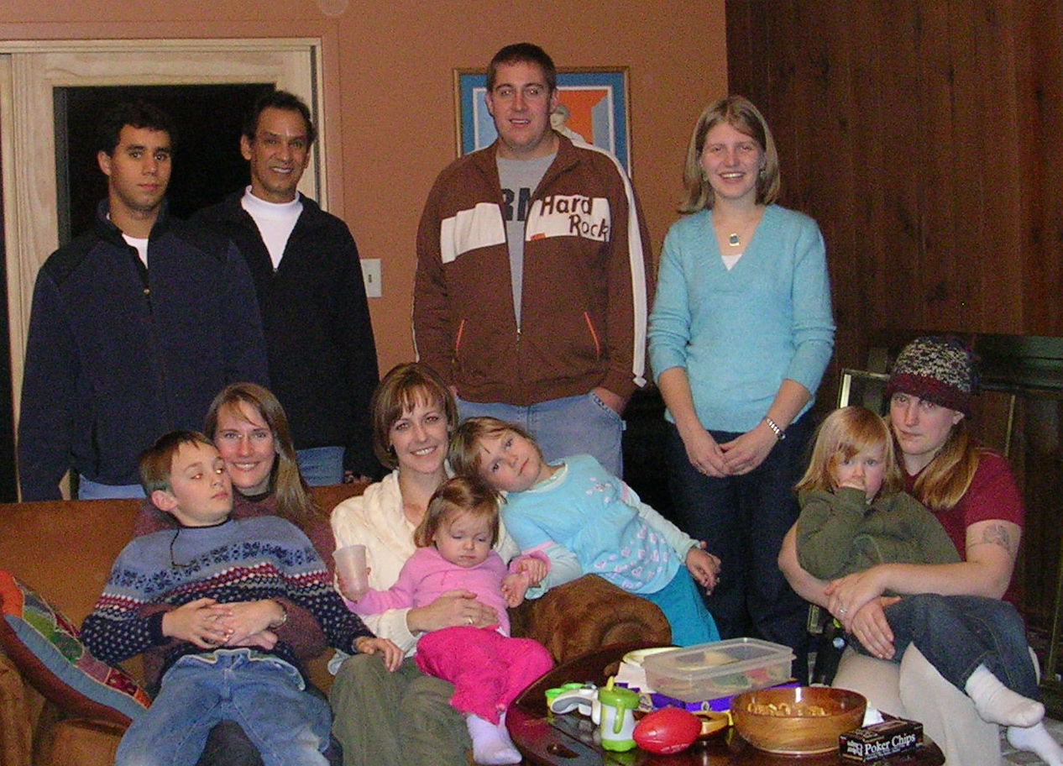 |  |  |  |  | Oscar Rocha  Associate Professor  Department of Biological Sciences  Kent State University  256 Cunningham Hall  Kent, OH 44242  Phone: (330) 672 2297  Fax: (330) 672 3713  Email: orocha@kent.edu |  | Lab members  Teaching  Publications
 |  | Research interests The goal of my work has been to study genetic variation in natural populations of plants and animals using molecular markers. I am interested in understanding how ecological factors, such as reproductive biology and human disturbances, affect the distribution of genetic variation. This information is useful for establishing conservation strategies for these populations. For more information on current projects click on the links below.
Biological invasions | Biology of tropical dry forest trees |  |  | Montane and Paramo vegetation |  | Genetic resources
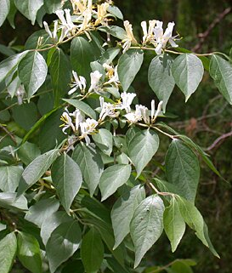 | 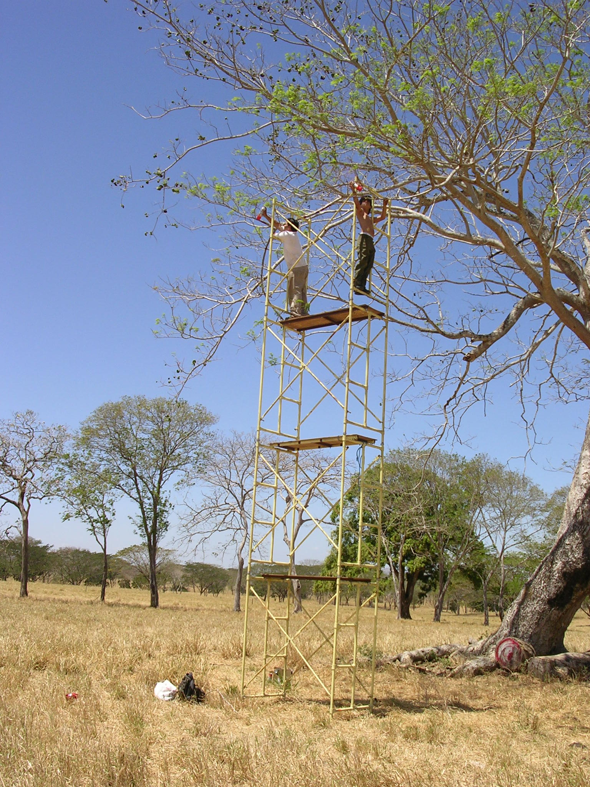 |  |  | 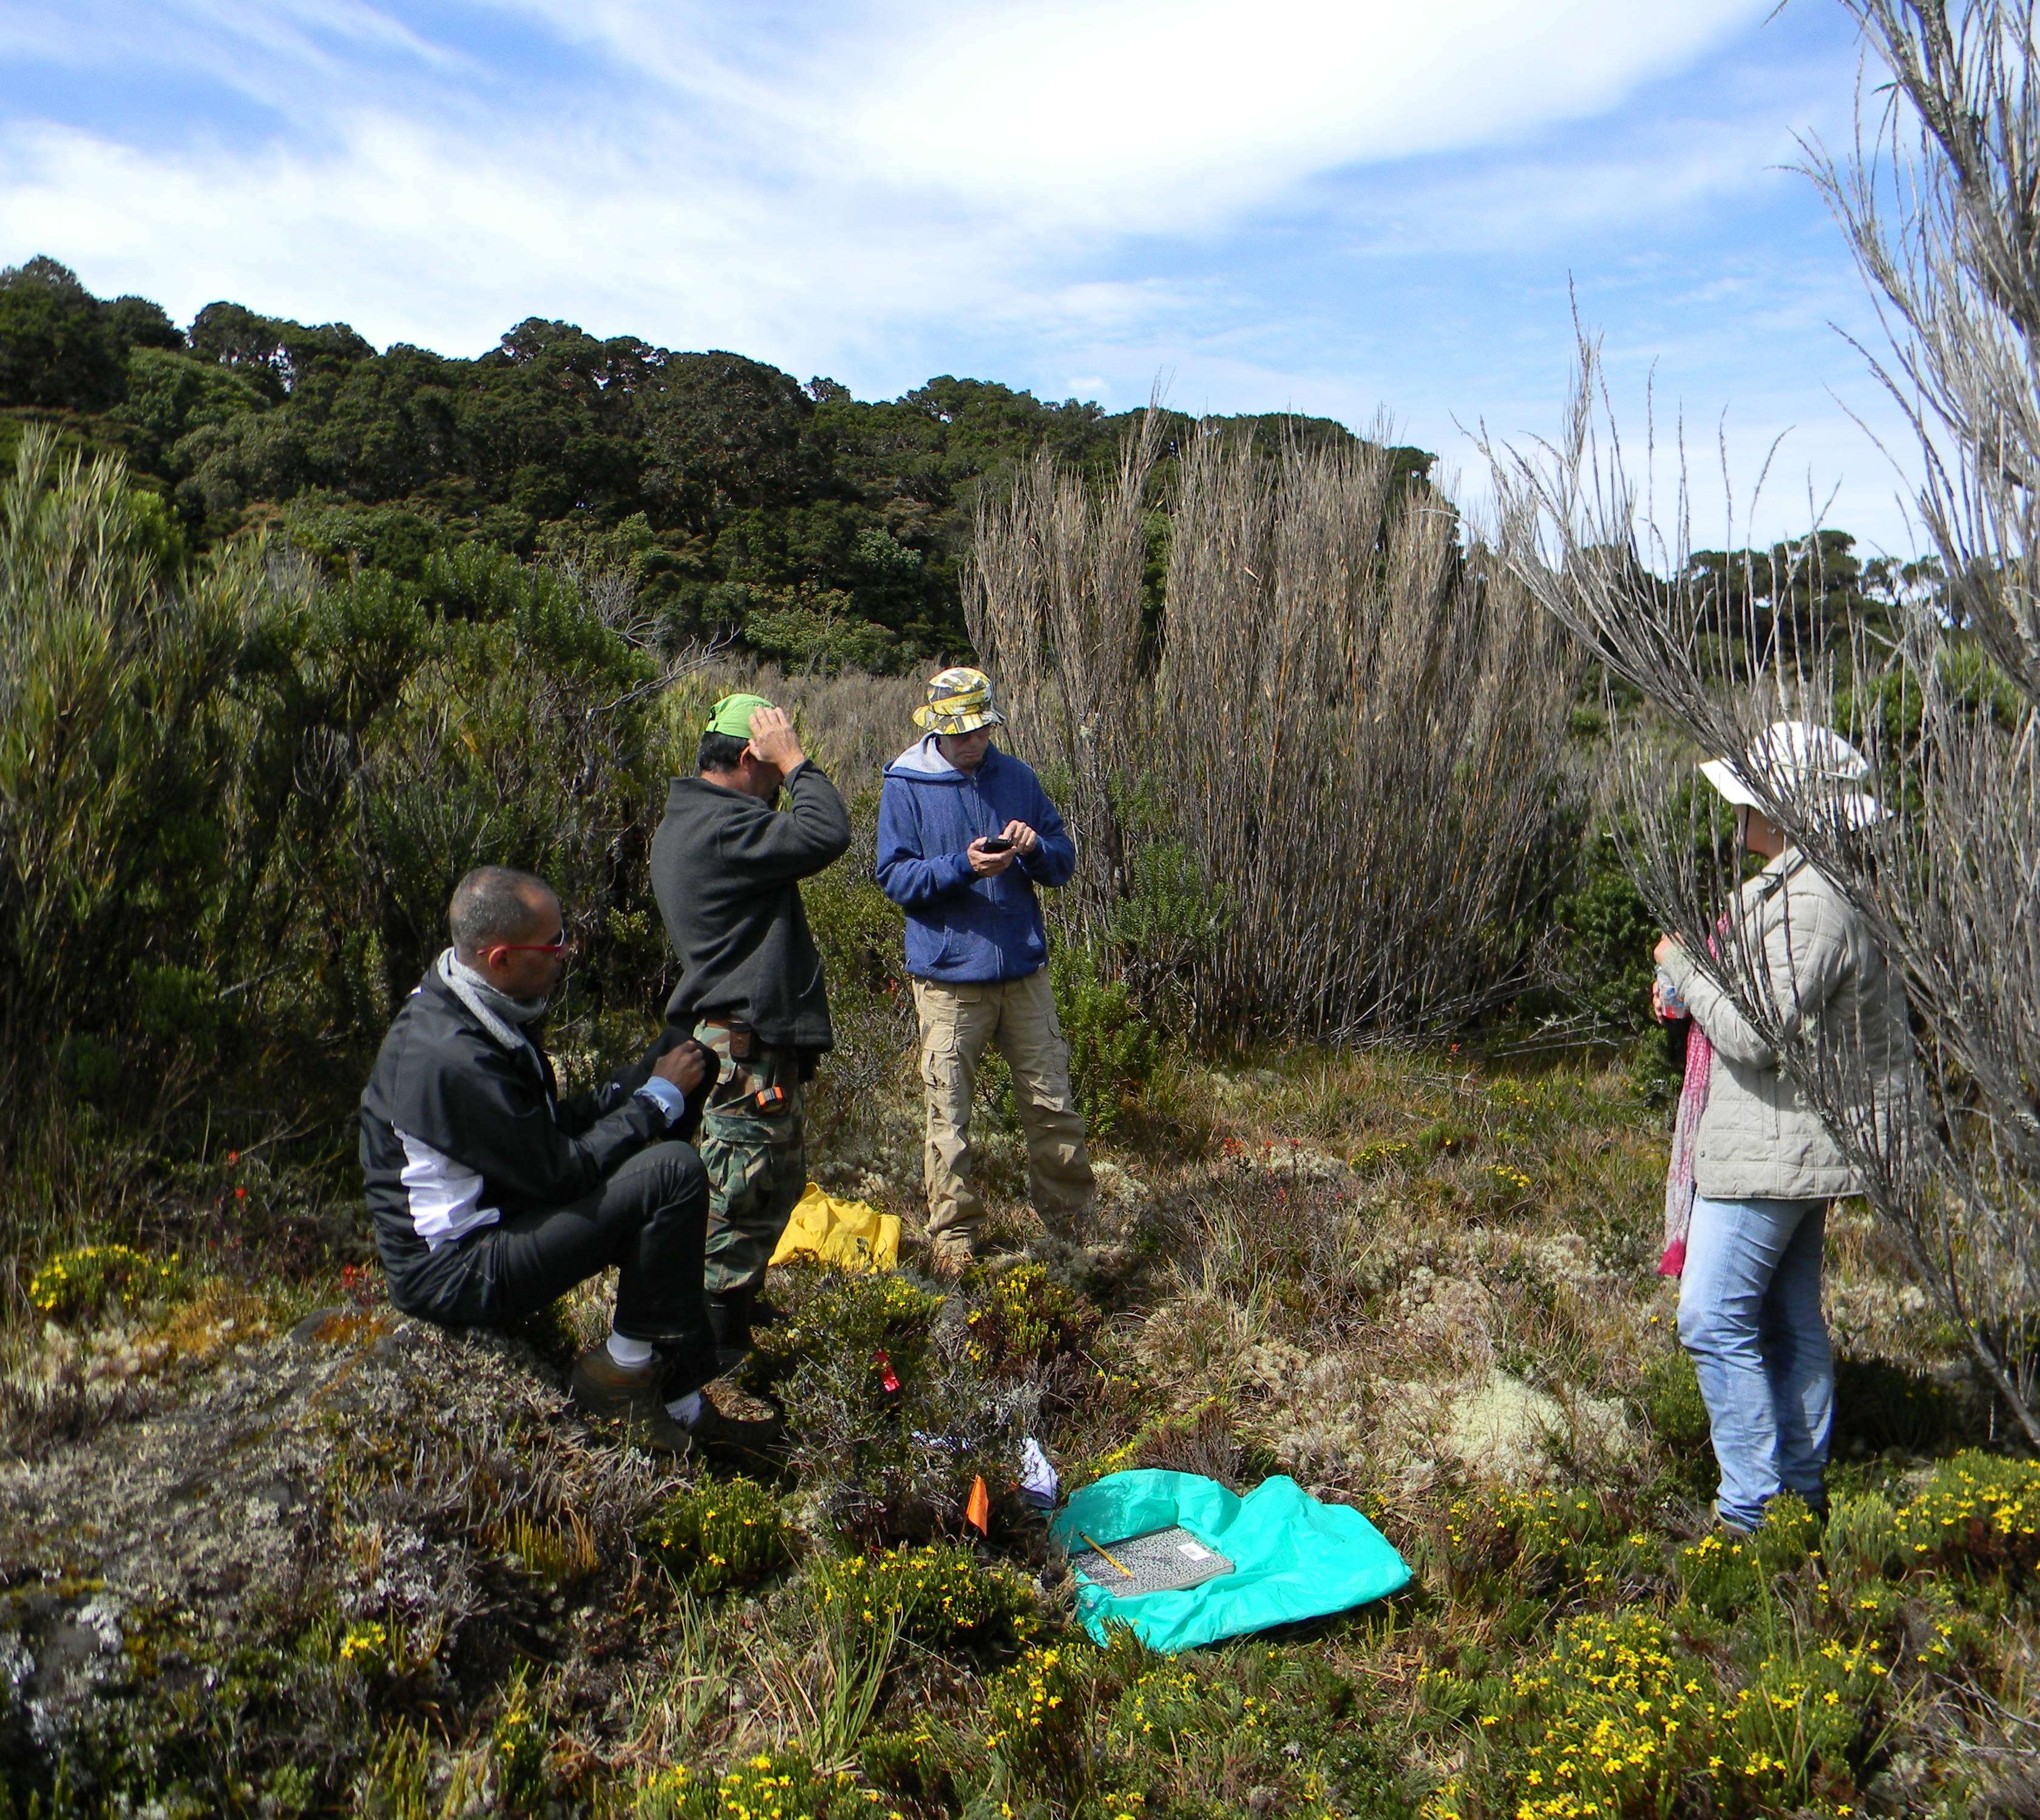 |  | 

